**Which WAN technology establishes a dedicated constant point-to-point connection between two sites?**

ATM  
Frame Relay  
**leased lines\***  
ISDN

**Which network scenario will require the use of a WAN?**

Employees need to access web pages that are hosted on the corporate web servers in the DMZ within their building.  
**Employees need to connect to the corporate email server through a VPN while traveling.\***  
Employee workstations need to obtain dynamically assigned IP addresses.  
Employees in the branch office need to share files with the headquarters office that is located in a separate building on the same campus network.

**What is a long distance fiber-optic media technology that supports both SONET and SDH, and assigns incoming optical signals to specific wavelengths of light?**

ATM  
MPLS  
ISDN  
**DWDM\***

**A customer needs a WAN virtual connection that provides high-speed, dedicated bandwidth between two sites. Which type of WAN connection would best fulfill this need?**

circuit-switched network  
packet-switched network  
MPLS  
**Ethernet WAN\***

**What is a feature of dense wavelength-division multiplexing (DWDM) technology?**

It replaces SONET and SDH technologies.  
It provides Layer 3 support for long distance data communications.  
It provides a 10 Gb/s multiplexed signal over analog copper telephone lines.  
**It enables bidirectional communications over one strand of fiber.\***

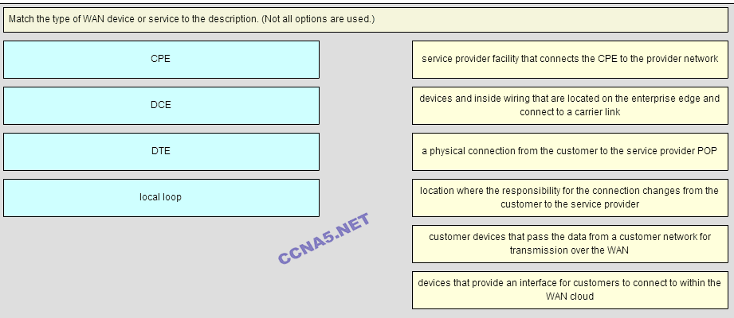

**Place the options in the following order:**

**- not scored –**   
**CPE**   
**Local Loop**   
**– not scored –**   
**DTE**   
**DCE**

**Which geographic scope requirement would be considered a distributed WAN scope?**

regional  
one-to-one  
global  
local  
one-to-many  
**many-to-many\***